National Workshop on “Pulses Development: Challenges and Opportunities in Central and Southern States” at ICAR-CIAE, Bhopal (M.P.)
on February 3-4, 2016

ICAR-Central Institute of Agriculture Engineering, Bhopal in collaboration with the Directorate of Pulses Development, Bhopal organized a two days National Workshop on “Pulses Development: Challenges and Opportunities in Central and Southern States” to commemorate the year 2016 as ‘International Year of Pulses’. The workshop was held during February 3rd-4th, 2016 at ICAR-CIAE, Bhopal and attended by more than 100 participants from different stake holders from Madhya Pradesh, Chhattisgarh, Gujarat, Maharashtra, Tamil Nadu, Telangana, Karnataka, Andhra Pradesh, Rajasthan and International and National Organization like ICRISAT, ICARDA, STC, CWC, ICAR-CIAE, ICAR-IIPR, ICAR-IISS, ICAR-CAZRI, ICAR-CRIDA, CSIR-CFTRI, Mahabeej, ICAR-ATARIs, State agriculture Universities, KVKs, Department of Agriculture of different states and Department of Agricultural Engineering, Bhopal, Directorate of Different Crops under DAC&FW, GoI etc.
The Annual production of about 18.32 million tonnes, is not sufficient to cater to the domestic demand of 22.42 million tonnes. The pulses requirement for the year 2030 is estimated to be 32 million tonnes; to meet the requirement, an annual growth rate of 4.2 % in production of pulses is therefore, necessary.
Major actionable points are given below:
- Abiotic Stress/Moisture Stress due to prevailing of droughts or long dry spell, coupled with inadequate irrigation facilities in and rising temperatures need a district-wise micro-irrigation system plan (MIS Plan) and implementation of Pradhan Mantri Krishi Sinchai Yojna (PKSY) in mission mode (Action - States/ RFS division /NRAA, DEC&FW).

- In view of limited availability of high quality seeds, poor SRR, Varietal Replacement Rate (VRR) and poor Varietal Diversification Rate (VDR), 10 years district specific seed rolling plan may be prepared during the current year of IYOP 2016 (Action - States/ICAR-IIPR/NSC/Seed Division of DAC&FW).

- Tur, Green, Black Gram and Horsegram are difficult to mill whereas, lentil , Peas, Bengalgram and Soybean are easy to mill pulses. To minimize quantitative and qualitative losses during dehulling, small and medium scale pulse processing units to empower the rural/small scale sector, these machineries may be distributed under the ongoing Development Programme i.e. NFSM-Pulses, RKVY. This will attract the farmers to fight malnutrition, fatch better prices and creating employment/ grinding of organically produce dhal. (Action - States/DAC&FW/ICAR-CIAE/CFTRI/ICAR-IIPR).
DHAL MILLS & THEIR AVAILABILITY
Dhal Mill | Capacity/hour | Source of Availability
Hand-operated pulses dehusker | 20-25 kg/h | CFTRI, Mysore  Webmail: www.cftri.com
Mini Dhal mill | 100-150 kg/h
Versatile Dhal Mill | 250-300 kg/h
Modern Dhal Mill | 1 TPH
Mini Versatile Dhal Mill | 100-150 kg/h
CIAE Dhal mill | 100 kg/h | ICAR-CIAE, Bhopal
IIPR Mini Dhal Mill | 75-125 kg/h | ICAR-IIPR, Kanpur
Pant Dhal Mill | 100-150 kg/h | G.B. Pant Agri. University, Pantnagar, Uttarakhand

- High occurrence of insect pest is a major challenge. The NCIPM studies have revealed 40-60 % damage in pigeonpea due to pod borer and 10-15 % due to wilt. Similarly, in gram this damages 10-90% (Pod Borer Complex) and 20-25% Due to Wilt/Root Rot. With the affective IPM the yield of pulses may be increase substantially (Pigeonpea -44%, Mung-> 40 %, Urdbean > 48%, Gram > 23% and Lentil 25%).
Projectile mode IPM demonstrations may be organized in potential districts to harness the production potential. The State Agricultural Universities, KVKs, NCIPM and these ICAR Zonal Research Stations may be given collaborative project underNFSM-Pulse/RKVY.(Action-States/NCIPM/ATARI/SAUs/ICAR-IIPR/DPD).

- A sizable portion of Area under pulses being with the SMF land holders, that too in rainfed regions, are resource poor and can not afford the machineries. This region have a very limited sowing window and need mechanization throughout the crop period. Large scale Custom Hiring Centers may be established/ strengthened with district-wise targets to facilitate mechanization.

The machinery/implements under CSS should also be mandated with the users group to be constituted by the individual beneficiaries for big machinery having subsidy of more than Rs. 10,000/-. (Action -SDA/Director Engineering States/ Machinery and Crop Division of DAC&FW, ICAR-CIAE).

- The existing yield gaps in Tur (Early duration-37% , Medium duration-71%); Mungbean (Kharif 73 %, Rabi-143 %); Urdbean (Kharif 68%, Rabi-51%); Gram (54% ) and Lentil (59%) is a major challenge.

Quality demonstration both by the states and ICAR (Including ATARI) need to be organized with full transparency, soil test based micro-nutrient applications and only need based quality inputs. (Action-States/SDAs/SAUs/ ATARI/ CDD/ NGOs/ DAC&FW).

- Quality inputs, especially micronutrients and pesticides (both organic and chemicals), Shortage of labour, competition from other commercial crops, lack of domestic level milling facility, high level of dust pollution in existing pulse milling industries, lack of scientific storage facility/technology and knowledge of fumigation at domestic level, strategies for effective branding and marketing of products should also need attention to address the pulse sector holistically.(Action-States/ DAC&FW).

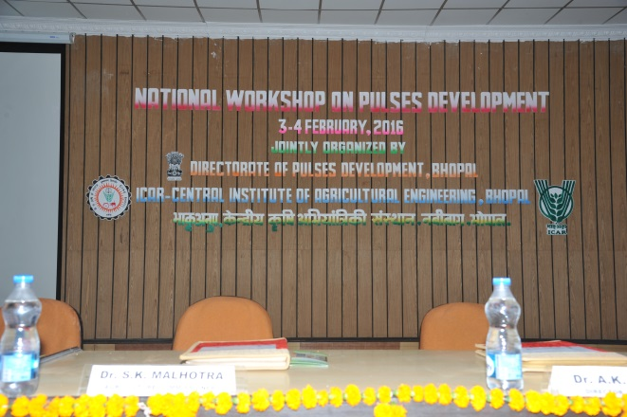 | 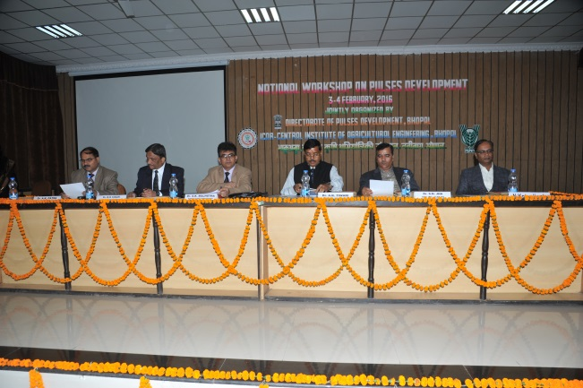
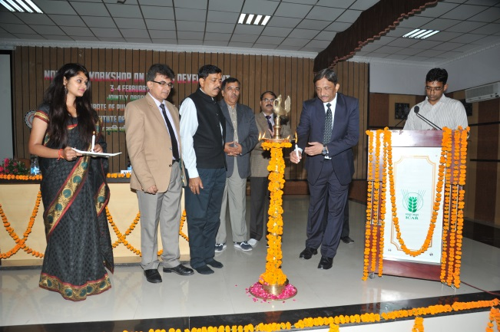 | 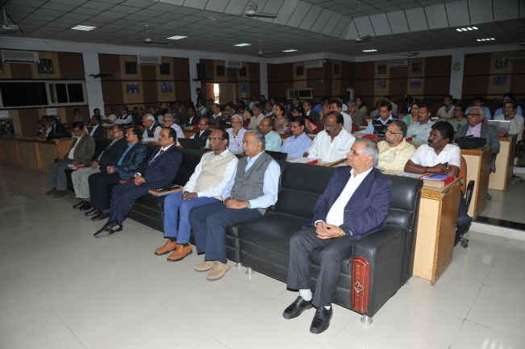
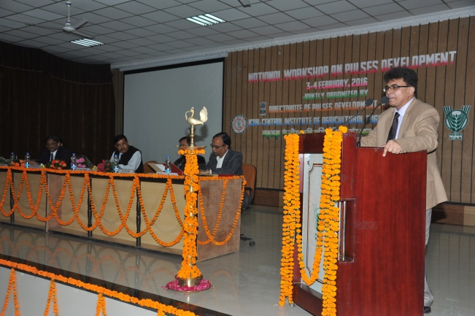 | 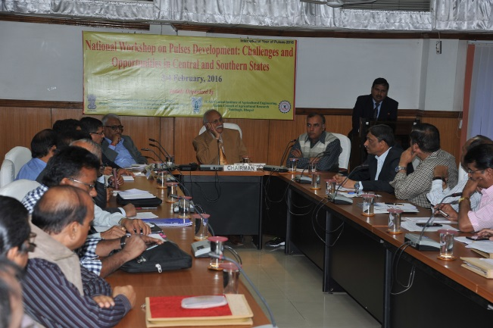
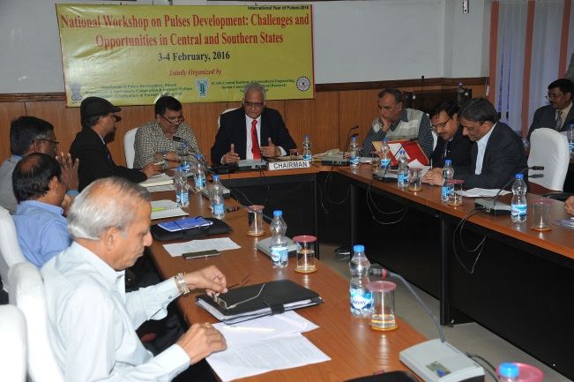 | 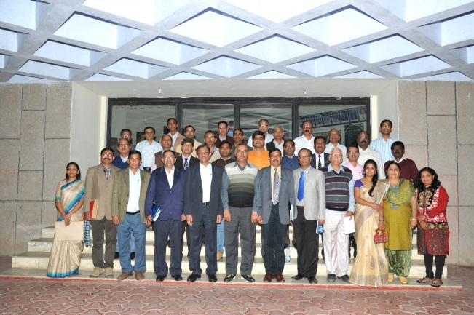
WORKSHOP PHOTOGRAPHS

